

**King Abdulaziz University**

**Faculty of Computing and Information Technology**

**Computer Science Department**

|  |  |  |  |
| --- | --- | --- | --- |
|  | | | |
| **Date** | **Version** | **Description** | **Authors** |
| 11/09/2022 | 0.1 | Phase 1: Project Description | All team members |
| 29/9/2022 | 0.2 | Phase 2: Business Requirements Specifications | All team members |
| 27/10/2022 | 0.3 | Phase 3: Static Modelling | All team members |
| 12/11/2022 | 0.4 | Phase 4: Modelling, Interaction & Behaviour | All team members |



**Version 0.4 Group ID: 8**

**Status: Draft Section: B9A**

[Saudi Cultural Heritage Application](https://lms.kau.edu.sa/webapps/blackboard/execute/modulepage/viewGroup?course_id=_458683_1&group_id=_361378_1)

Contents

Project Team 4

1. Phase 1: Project Description 4

1.1 Introduction 4

1.2 Problem Description 4

1.3 Project Objectives 5

1.4 Project Goals 5

1.5 Sources of Domain Analysis Information 5

1.6 Scope of The System 5

1.6.1 The system includes: 6

1.6.2 The system excludes: 6

1.7 System's Stakeholders 6

2. Phase 2: Business Requirements Specifications 6

2.1 Requirements 6

2.1.1 Functional Requirements 6

2.1.2 Non-Functional Requirements 7

2.2 Techniques for Gathering Data 8

2.3 Use Case Diagram 9

2.4 Use Case Description 10

2.5 Difficulties & Risk Analysis in the Domain 12

3. Phase 3: Static Modelling 13

3.1 Domain Model 13

3.2 UML Class Diagram 14

3.2.1 Association relationships 15

3.2.2 Aggregation relationships 15

3.2.3 Generalization 15

3.3. System Architecture 16

3.3.1. Type of The System 16

3.3.2. Architectural Design 16

4. Phase 4: Modelling, Interaction & Behaviour 17

4.1 Interaction Diagram 17

4.1.1 Sequence Diagram 17

4.1.2 State Diagram 19

4.1.3 Activity Diagram 20

4.2 Testing 22

4.2.1 Objectives 22

4.2.2 Testing strategy 22

4.2.3 Approach 22

4.2.3 Test Plan 23

4. Appendix 27

Appendix A 27

Appendix B 28

Appendix B.1 28

Appendix B.2 29

Tables

Table 1 Team Members 4

Table 2 Use Case Description 1 (Create Account) 10

Table 3 Use Case Description 2 (Make Order) 11

Table 4 Use Case Description 3 (Manage Order) 11

Table 5 Use Case Description 4 (Add New Site) 12

Table 6 Test Plan 1 (Create Account) 23

Table 7 Test Plan 1 (Create Account) - Decision Table Testing 23

Table 8 Test Plan 2 (Manage List) 24

Table 9 Test Plan 2 (Manage List) - Boundary Value Analysis 25

Table 10 Test Plan 3 (Cancel Order) 26

Table 11 Test Plan 3 (Cancel Order) - Equivalence Partitioning 26

Figures

Figure 1 Use Case Diagram 9

Figure 2 Domain Model 13

Figure 3 UML Class Diagram 14

Figure 4 Architectural Design 16

Figure 5 Sequence Diagram (Create Account) 17

Figure 6 Sequence Diagram (Log-in) 18

Figure 7 State Diagram (Create Account) 19

Figure 8 State Diagram (Manage Order) 19

Figure 9 Activity Diagram (Create Account) 20

Figure 10 Activity Diagram (Make Order) 21

Figure 11 Survey results 27

Figure 12 A clear picture of Domain Model 28

Figure 13 A clear picture of UML Class Diagram 30

# Project Team

|  |  |  |
| --- | --- | --- |
|  | | |
| **Name** | **ID** | **Work distribution percentage** |
| Asal Ali Alghamdi (Leader) | 2005517 | 100 % |
| Dhay Mohammed Alharbi | 1905483 | 100 % |
| Mayar Mohammed Alswill | 2005209 | 100 % |
| Hadeel Abdullah Abuhamous | 2006291 | 100 % |

Table Team Members

# 1. Phase 1: Project Description

## 1.1 Introduction

Culture is an essential component of a country because it expresses the country and its history. As a result, we must preserve our heritage because it is the source of our origin and deep roots. Furthermore, the Saudi Vision 2030 focused on culture and established a special ministry for culture, indicating the significance of culture in Saudi Arabia. So, we need an application that educates citizens and tourists about Saudi cultural heritage.

In our project “**Saudi cultural heritage application**”, we want to create an application about Saudi Arabia's heritage, including various cultural categories such as clothing, food, and dances. To raise heritage culture awareness, educate citizens and tourists about Saudi Arabia's cultural heritage, and achieve Saudi Vision 2030.

## 1.2 Problem Description

The main problem is that Saudi citizens and tourists are unaware of the country's cultural heritage. In our project, we want to create an application that allows users to discover Saudi cultural heritage for a variety of Saudi Arabian regions by navigating through various sections in the application, which include:

* Traditional clothes with the possibility of delivery
* Traditional food with its recipes
* Houses
* Tourist attractions
* Beauty is like old hairstyles and makeup with the possibility of delivery of available products
* Traditional dances
* Weddings and historical events

That will be through information, photos, and videos, with the provision of delivery to some categories to enable users to purchase and increase their knowledge of the heritage culture in Saudi Arabia.

## 1.3 Project Objectives

* Allows users to learn about Saudi Arabian heritage
* Allow users to view different regions of Saudi Arabia and learn about each one of them
* Educate users by learning about the history of each region
* It shows users the customs of each region and the different information about it, such as their food, clothes, marriage traditions, etc
* Provide delivery service for some of the available old products
* Encouraging tourists to visit Saudi Arabia and endearing them to our culture
* ‏Increasing the Kingdom's economy through tourists by introducing them to our heritage and the tourist places in the Kingdom of Saudi Arabia

## 1.4 Project Goals

The primary goals of the project are to increase the economy of the Kingdom of Saudi Arabia because of tourism. The increase in the number of tourists and to get to know the beauty of the Kingdom of Saudi Arabia because of the 2030 vision.

Some other goals:

* Take advantage of modern technology to develop the country
* Spreading Saudi culture
* Make it easier to reach tourist places and get to know our civilization easily
* Visitors and tourists can choose the areas that best suit their needs and interests

## 1.5 Sources of Domain Analysis Information

The project will help and encourage many tourists, as it will serve them by knowing the famous tourist areas in the Kingdom of Saudi Arabia and what distinguishes each region.

We can get information about the tourist and heritage areas from tour guides, the elderly, and residents of heritage areas, benefiting from the experiences of previous visitors. It is also possible to collect information from books, articles and websites specialized in the civilizations and heritage of the Kingdom of Saudi Arabia.

## 1.6 Scope of The System

The project is an application that helps to facilitate the search and find information related to each region of the Kingdom separately so that the experience of visitors and tourists becomes enjoyable to the maximum. The application provides information about heritage and tourist places worth visiting, information about its history, and provides stores for selling famous products related to the region.

### 1.6.1 The system includes:

* General information about the regions of Saudi Arabia
* The famous tourist places in the specified area
* Heritage and historical places in the specified area
* Information about the history of the region, including popular dishes, fashion and beauty, customs, and traditions of occasions such as marriage
* The ability to order and deliver popular products from the region

### 1.6.2 The system excludes:

* The ability to book tickets for the visit
* Knowing the status of places and locations (closed - open)

## 1.7 System's Stakeholders

The stakeholders and those affected by our project are the owners and beneficiaries of tourist and heritage places, owners of shops selling tourism and heritage products, delivery companies, visitors, and tourists who will use the application.

The project is expected to be completed by the end of the current semester.

# 2. Phase 2: Business Requirements Specifications

## 2.1 Requirements

### 2.1.1 Functional Requirements

R1. The system shall allow user to create an account.

R1.1. The system shall allow user to view their profile.

R1.2. The system shall allow user to modify their profile.

R2. The system shall allow the user to enter his personal information.

R3. The system shall allow the user to choose whether they are a visitor or a seller.

R4. The system should allow the user to activate the GPS access to the system.

R5. The user shall be able to write and review other comments.

R6. The system shall allow the visitor to make lists.

R6.1. The system shall allow the visitor to make a list of their favourite places.

R6.2. The system shall allow the visitor to make a list of their visited places.

R6.3. The system shall allow the visitor to make a list of places they want to visit.

R7. The system shall allow visitor to view the tourist and historical sites.

R7.1. The system shall allow visitor to view the historical places by a map.

R7.2. The system shall allow visitor to view the historical places by an alphabetically ordered list.

R8. The system shall allow visitor to view the closest stores to order from.

R8.1. The system shall allow visitor to view the closest stores to order from according to the nearest to their location.

R8.2. The system shall allow visitor to view the closest stores to order from in an alphabetical order.

R9. The system shall allow visitor to view the description and history of the chosen site and all the other details related to it.

R10. The system shall ask the user to log in.

R11. The system shall allow the seller to accept or reject orders.

R12. The system shall allow the visitor to view the order records and customers comments.

R13. The system shall allow the visitor to choose between delivery or receipt.

R14. The system shall allow the visitor to place an order.

R15. The system shall allow the visitor to track his order process.

R15.1 The system shall allow the visitor to view expected order arrival time.

R16. The system shall allow the admin to add new sites and manage its information.

R17. The system shall allow the visitor and the seller to communicate within the system.

R18. The system shall provide Apple Pay or card payment.

R19. The system shall be able to calculate the total of the cart.

R20. The system shall be able to send the order's receipt to the visitor

R21. The system shall allow the seller to add a new store.

R22. The system shall allow the seller to update the store.

R22.1. The system shall allow the seller to add a new product to the store.

R22.2. The system shall allow the seller to update the product price.

R22.3. The system shall allow the seller to update the product picture.

R22.4. The system shall allow the seller to delete the product.

R23. The system shall ask the users to log out.

R24. The system shall prompt the users to approval the application permissions before signing up.

### 2.1.2 Non-Functional Requirements

R1. For developers, adding new feature should be an easy process and should not involve any coding process.

R2. For developers, set one day each month for monitoring, development, and troubleshooting.

R3. The application must be suitable for all phones.

R4. The application should be able to run at rate of 80 frames/second to provide smooth frame transition.

R5. The application should be able to receive more than 1000 users at the same time.

R6. The application shall be easy to use, training time for non-technical visitor shall be less than 3 minutes.

R7. The application shall be easy to modify, programmers shall be able to change default setting in less than 3 minutes.

R8. Screen must give enough information for the visitors about the application in the first time using the app.

R9. The system shall be in Arabic and English.

## 2.2 Techniques for Gathering Data

We collected data using a survey directed at residents and citizens in general, to ask them about their knowledge of the tourist and heritage areas of their region, to see the results of the survey, please look at **Appendix A**. We have also reached out to some famous travellers, asking them what information they need to know before traveling, places they would like to visit when they travel, and, if there is an app that helps them collect this information easily, what services they would like to have in it.

After collecting and analyzing the information, we concluded that travelers and tourists need some information and services that help them make their experience better and more enjoyable, including:

* Information about tourist, heritage, and historical attractions
* Food that are famous and special to the area
* Products that are famous and special to the area, such as clothes, accessories, etc

## 2.3 Use Case Diagram

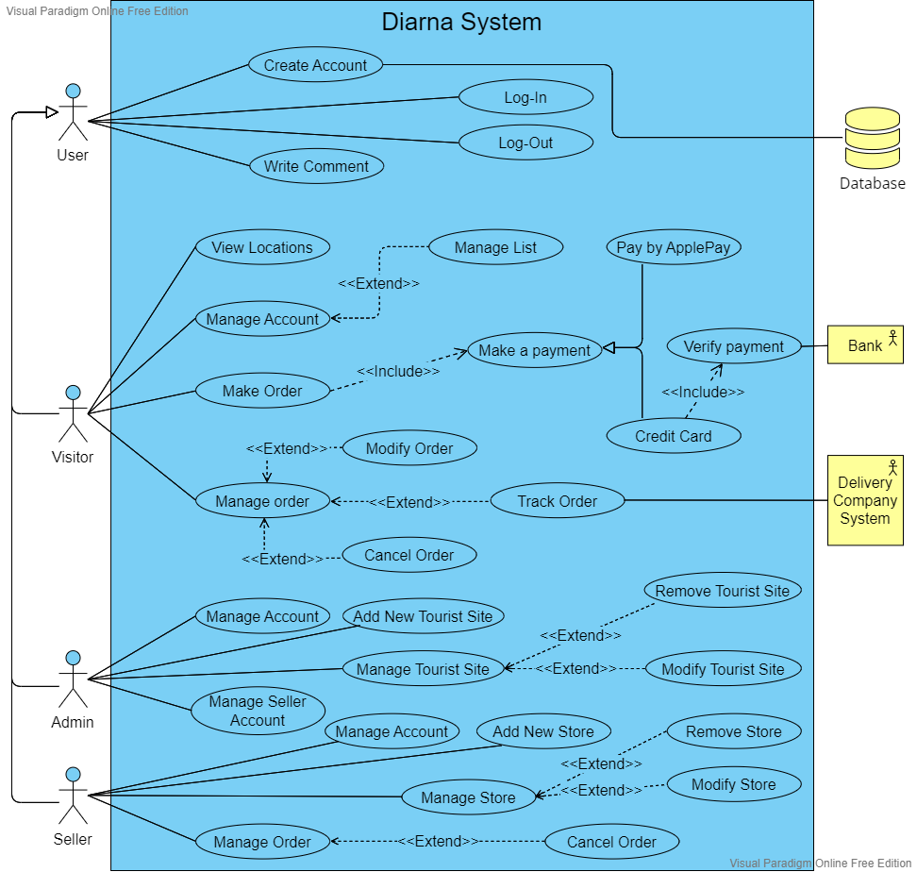

Figure Use Case Diagram

## 2.4 Use Case Description

|  |
| --- |
| Create Account |
| **Brief Description:** Users must create account to use the program. |
| **Actors:** User. |
| **Precondition:** None. |
| **Basic Flow of Events:**   * The actor can open the program from his/her phone or desktop screen * The actor can create an account by clicking on create account button from the main interface * The actor fills the requirement fields with necessary correct information about his or her age, an email, phone number and their location * The account is saved in the system and the profile is created |
| **Extension:**   * The system fails to create an account * The actor filled the requirement fields with wrong information * The user has already registered |
| **Postcondition:** The account must be created to take the advantages of the program. |
| **Special requirement:** To create the account the user must be connected to the internet. |

Table Use Case Description 1 (Create Account)

|  |
| --- |
| Make Order |
| **Brief Description:** The app shows all the products that are available to a user. When a visitor logs in, he can choose and buy whatever he wants. |
| **Actors:** Visitor. |
| **Precondition:** The visitor logged into the application. |
| **Basic Flow of Events:**   * Click on the shopping tab * Choosing the right products * ‏Press ok * ‏Choose the payment method and receiving method. * ‏After verification is completed, payment will be made * A tracking number appears |
| **Extension:**   * System Down * The card has failed verification |
| **Postcondition:** Complete your purchase. |
| **Special requirement:** To make an order the visitor must be connected to the internet. |

Table Use Case Description 2 (Make Order)

|  |
| --- |
| Manage Order |
| **Brief Description:** The seller accepts or rejects the order that a visitor has made. |
| **Actors:** seller. |
| **Precondition:**  The seller login into the system.  The visitor has made an order. |
| **Basic Flow of Events:**  1. The seller presses the manage orders button.  2. The seller chooses from the list of their orders.  3. The seller chooses a button to accept or reject the order.  4. The seller updates the orders and manages to inform the visitor that his order has been accepted or rejected. |
| **Extension:**  2a Seller does not have any orders.  2a1 The system displays an error message saying there are no orders. |
| **Postcondition:** The seller has completed his order management. |
| **Special requirement:**  The user registers in the system as a seller.  To manage an order the seller must be connected to the internet. |

Table Use Case Description 3 (Manage Order)

|  |
| --- |
| Add New Site |
| **Brief Description:** Add new site to the application with all its details. |
| **Actors:** Admin. |
| **Precondition:** The admin logged into the application. |
| **Basic Flow of Events:**   * Admin selects “Add new site” option from the menu * Write the required information about the new site * Admin click “Add” button * New site added to the system |
| **Extension:**   * The system fails to add the site * The actor filled the requirement fields with wrong information * The site has already been added |
| **Postcondition:** The site shows in the sites list. |
| **Special requirement:** To add a new site the admin must be connected to the internet. |

Table Use Case Description 4 (Add New Site)

## 2.5 Difficulties & Risk Analysis in the Domain

* The public generally lacks knowledge of and interest in Saudi heritage
* Requirements may change as the project progresses
* Difficulties in gathering the required data

# 3. Phase 3: Static Modelling

## 3.1 Domain Model

Figure Domain Model

There is a clearer picture of Domain Model in **Appendix B.1**

## 3.2 UML Class Diagram

Figure UML Class Diagram

There is a clearer picture of UML Class Diagram in **Appendix B.2**

### 3.2.1 Association relationships

Between **Visitor** and **Order** classes:

* A Visitor can make 0 or more Order
* An Order can be made by 1 Visitor

Between **Admin** and **Visitor** classes:

* An Admin can manage 0 or more Visitor accounts
* A Visitor account can be manged by 1 or more Admins

Between **Admin** and **TouristSite** classes:

* An Admin can add 0 or more TouristSite
* A TouristSite can be added by 1 or more Admin

Between **Admin** and **Seller** classes:

* An Admin can manage 0 or more Seller accounts
* A Seller account can be manged by 1 or more Admins

Between **Seller** and **Store** classes:

* A Seller can own 0 or more Store
* A Store can be owned by one Seller

Between **Seller** and **Product** classes:

* A Seller can add 0 or more Product
* A Product can be added by one Seller

Between **Seller** and **Order** classes:

* A Seller can manage 0 or more Order
* An Order can be managed by one Seller

### 3.2.2 Aggregation relationships

Between **Product** and **Store** classes:

Products could be available in one store, and the store could have one or more products.

### 3.2.3 Generalization

Visitors, admins, and sellers inherit users’ attributes and functions.

## 3.3. System Architecture

### 3.3.1. Type of The System

We chose N-tier architecture because our system involves user interaction from the start till the end. For example, the visitor can make order, the system will handle the visitor's instruction and will display the products then the visitor can choose products and then visitor should pay.

### 3.3.2. Architectural Design

N-tier architecture is used with this interactive system.

Figure Architectural Design

# 4. Phase 4: Modelling, Interaction & Behaviour

## 4.1 Interaction Diagram

### 4.1.1 Sequence Diagram

#### Diagram Description automatically generated4.1.1.1 Create Account

Figure Sequence Diagram (Create Account)

#### 4.1.1.2 Log-in

Figure Sequence Diagram (Log-in)

### 4.1.2 State Diagram

*4.1.2.1 Create Account*

Figure State Diagram (Create Account)

*4.1.2.2 Manage Order*

Figure State Diagram (Manage Order)

### 4.1.3 Activity Diagram

*4.1.3.1 Create Account*

Figure Activity Diagram (Create Account)

*4.1.3.2 Make Order*

Figure Activity Diagram (Make Order)

## 4.2 Testing

### 4.2.1 Objectives

We created some test plans and strategies to test and identify the system errors and defects and ensure that the system will work and behave as expected.

### 4.2.2 Testing strategy

The purpose of the test is to ensure that the system is operating properly and meets the requirements. The use cases that we created a test case for are: Create Account (of a Visitor type), Manage List, Cancel Order. For pass/fail criteria, we considered the test case to be successful and it passes the test if the system behaves and gives the expected result, otherwise we considered it to be a failed test case.

### 4.2.3 Approach

We used the black box testing approach for our test case plans. We prepared a scripted input for each test case and compared the output of the system with the expected output.

### 4.2.3 Test Plan

#### 4.2.3.1 Test Plan 1

Test case name: Create Account (for a visitor account type).

Description: Testing the process of creating a new account, considering the cases where the account is already existed.

|  |  |  |  |  |  |  |
| --- | --- | --- | --- | --- | --- | --- |
| **Test Case ID** | **Test Scenario** | **Test Steps** | **Test Data** | **Expected Results** | **Actual Results** | **Pass/ Fail** |
| 1 | Check how the system would behave if the user entered a valid information for registration (account has never been registered before). | 1. Click on “Sign in” tab 2. Choose the account type 3. Enter the required information 4. Click “Create account” tab | Account type: Visitor  Account information: unique account information | Account created successfully. |  |  |
| 2 | Check how the system would behave if the user entered an invalid information for registration (account is already registered). | 1. Click on “Sign in” tab 2. Choose the account type 3. Enter the required information 4. Click “Create account” tab | Account type: Visitor  Account information: an existed account information | System should inform the user that the account already exists. |  |  |

Table Test Plan 1 (Create Account)

**Applying Test Design Technique “Decision Table Testing” on the uniqueness of (name/phone number OR e-mail)**

|  |  |  |  |  |
| --- | --- | --- | --- | --- |
| **Username** | T | T | F | F |
| **Phone number OR E-mail** | T | F | T | F |
| **Expected result** | Create account successfully | Error message: “This Phone number/E-mail have been used before” | Error message: “This Username have been used before” | Error message: “This Phone number/E-mail have been used before” |

Table Test Plan 1 (Create Account) - Decision Table Testing

#### 4.2.3.2 Test Plan 2

Test case name: Manage List.

Description: Testing the process of removing saved locations, considering the list status.

|  |  |  |  |  |  |  |
| --- | --- | --- | --- | --- | --- | --- |
| **Test Case ID** | **Test Scenario** | **Test Steps** | **Test Data** | **Expected Results** | **Actual Results** | **Pass/ Fail** |
| 1 | Check how the system would behave if the user wanted to remove some saved location from their list. | 1. Log-in 2. Click on “Account information” tab 3. Click on “My list” tab 4. Click on “Modify list” tab 5. Choose locations to be removed 6. Click “Ok” tab | Location: 4 locations.  List status: not empty. | Locations removed successfully from the user list. |  |  |
| 2 | Check how the system would behave if the user wanted to remove some saved location from their empty list. | 1. Log-in 2. Click on “Account information” tab 3. Click on “My list” tab 4. Click on “Modify list” tab | Locations: None.  List status: empty. | System should show massage to the user “The list is empty; you cannot modify an empty list”. |  |  |
| 3 | Check how the system would behave if the user wanted to remove some saved location from their list but choose less than the lower boundary (1 location). | 1. Log-in 2. Click on “Account information” tab 3. Click on “My list” tab 4. Click on “Modify list” tab 5. Choose locations to be removed 6. Click “Ok” tab | Locations: 0 location.  List status: not empty. | System should show massage to the user “You should choose at least 1 location to be removed”. |  |  |
| 4 | Check how the system would behave if the user wanted to remove some saved location from their list and choose more than the upper boundary (10 locations). | 1. Log-in 2. Click on “Account information” tab 3. Click on “My list” tab 4. Click on “Modify list” tab 5. Choose locations to be removed 6. Click “Ok” tab | Locations: 15 locations.  List status: not empty. | System should show massage to the user “You should choose at most 10 locations to be removed”. |  |  |

Table Test Plan 2 (Manage List)

**Applying Test Design Technique “Boundary Value Analysis” on number of the locations chose (1 to 10)**

|  |  |  |  |
| --- | --- | --- | --- |
| **Invalid Partition - Valid Partition**  **Lower Boundary (1 Location at least)** | | **Valid Partition - Invalid Partition**  **Upper Boundary (10 Locations at most)** | |
| **Below the boundary** | **Above the boundary** | **Below the boundary** | **Above the boundary** |
| 0 location | 1 location | 10 locations | 11 locations |

Table Test Plan 2 (Manage List) - Boundary Value Analysis

#### 4.2.3.3 Test Plan 3

Test case name: Cancel Order.

Description: Testing the process of cancelling an order, considering the order status.

|  |  |  |  |  |  |  |
| --- | --- | --- | --- | --- | --- | --- |
| **Test Case ID** | **Test Scenario** | **Test Steps** | **Test Data** | **Expected Results** | **Actual Results** | **Pass/ Fail** |
| 1 | Check how the system would behave if the user wanted to cancel an order before handing it over to the delivery company. | 1. Log-in 2. Click on “Account information” tab 3. Click on “My orders” tab 4. Click on the order to be canceled 5. Click on “Cancel Order” | Order: selected order.  Order status: has not arrived at the delivery company yet. | Order canceled successfully.  Payment refunded successfully. |  |  |
| 2 | Check how the system would behave if the user wanted to cancel an order after handing it over to the delivery company. | 1. Log-in 2. Click on “Account information” tab 3. Click on “My orders” tab 4. Click on the order to be canceled   Click on “Cancel Order” | Order: selected order.  Order status: has arrived at the delivery company. | System should show massage to the user “The order has arrived at the delivery company already; order cannot be canceled”. |  |  |

Table Test Plan 3 (Cancel Order)

**Applying Test Design Technique “Equivalence Partitioning” on the Order Status (handed/not handed)**

|  |  |
| --- | --- |
| **Valid Partition** | **Invalid Partition** |
| Order status is “not handed to the delivery company” | Order status is “handed to the delivery company” |

Table Test Plan 3 (Cancel Order) - Equivalence Partitioning

# 4. Appendix

## Appendix A

Result of survey:

Figure Survey results

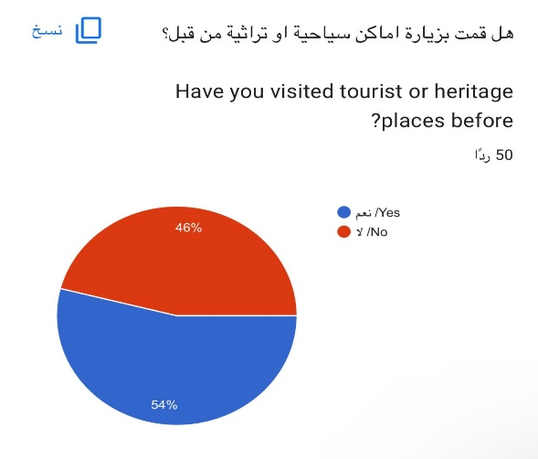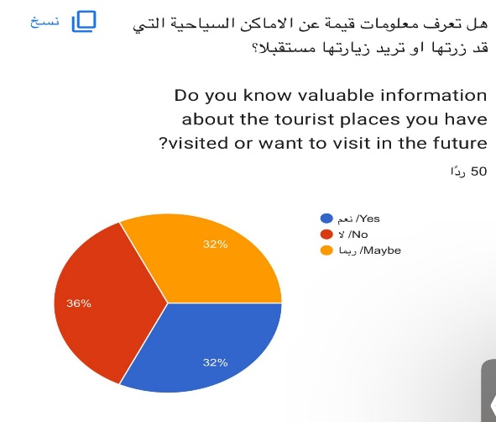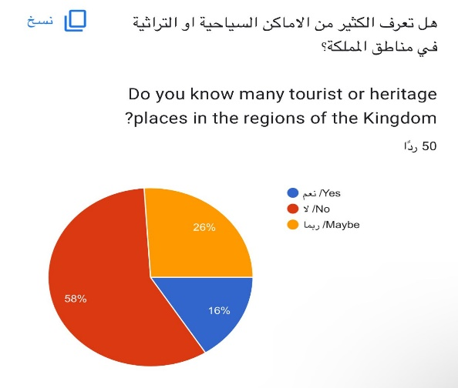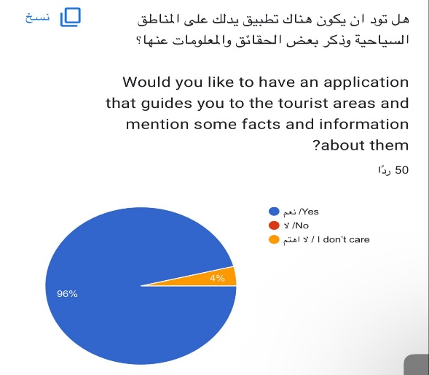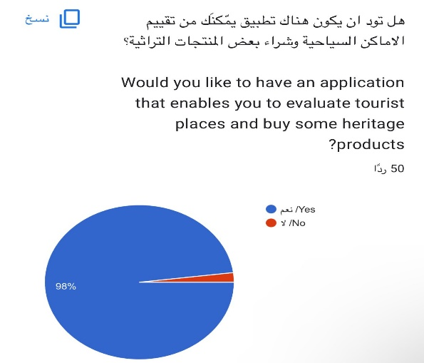

# 

## Appendix B

### Appendix B.1

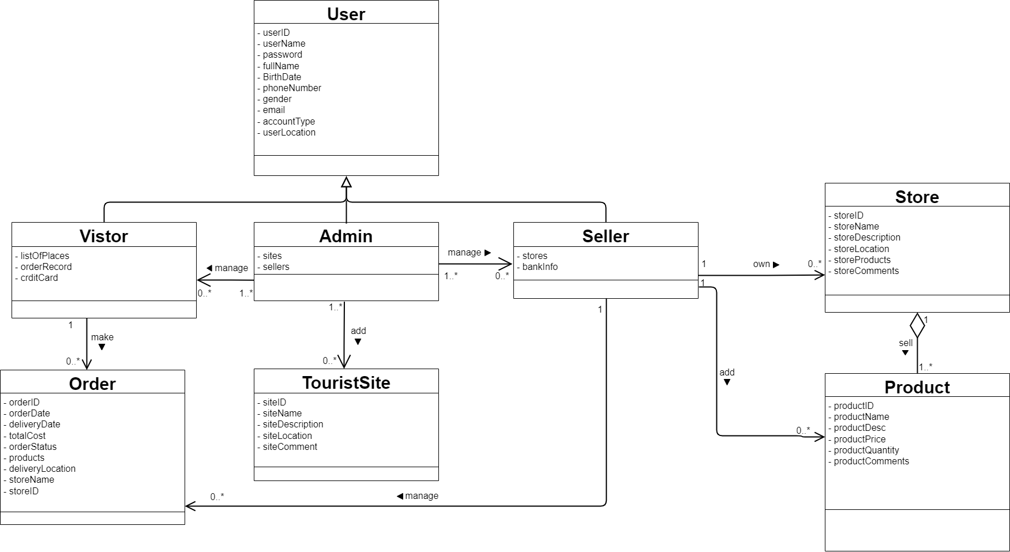

Figure A clear picture of Domain Model

### Appendix B.2

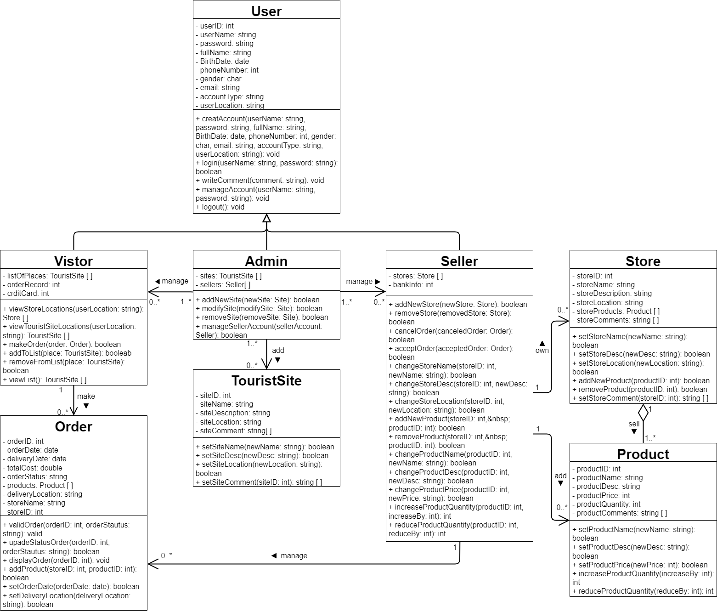



Figure A clear picture of UML Class Diagram